case study title here (15 words max)

Author One ¹, Author Two ², Author Three ²
1. Organisation, Melbourne, VIC, Australia
2. Another Organisation, Sydney, NSW, Australia

This document explains how to prepare a case study for submission to the Palliative Care NSW 2026 State Conference. The headings outlined on this template are the headings to be used in your submission (Keywords, Executive Summary, Introduction, Year Case Study was Implemented, Case Study Detail)
It is important this template is adhered to as all case studies accepted for presentation will be made available to attendees as submitted, noting that there will be an opportunity to provide an updated version if the case study is accepted. DELETE THESE EXPLANATORY NOTES WHEN PREPARING YOUR CASE STUDY AND BEFORE SUBMITTING.

Keywords
Please list a minimum of three (3) keywords

EXECUTIVE SUMMARY (100 words maximum)
If submission is successful, the 100 words will be used in pre-Conference promotion.

introduction

YEAR CASE STUDY WAS IMPLEMENTED
20__ to 20__

CASE STUDY DETAIL
Maximum of 700 words providing an overview of the activity addressing the points below.
- The specific issue being addressed.
- Approach developed to address this issue.
- Summary of activities and their implementation.
- Summary of outcomes and measurable impacts of the activities.
- The extent to which the activity is scalable and ease of adoption by other services / organisations.
- Important lessons learnt and critical success factors.
- Other comments/information

OTHER IMPORTANT NOTES FOR PREPARING YOUR CASE STUDY – DELETE THIS HEADING AND EVERYTHING BELOW BEFORE SUBMITTING YOUR CASE STUDY

Page Limit
Maximum 2 pages of text followed by a maximum of 3 pages of supporting tables and graphics.

Page Size and Layout
The paper should be prepared for A4 size paper (210 x 297mm), with overall margins of 20mm on all sides of the paper (top, bottom, right and left). Use font type Arial for the entire document. Justify text.
Do not include page numbers, headers or footnotes.

Abstract Title and Affiliations
The top section of the first page of the paper should contain the case study title, author list, and affiliations.

Titles must be in 12-point font, bold and capitalised. Do not use more than two lines for the title,and try to limit the title to ten words.

Authors and affiliations must be in 10-point font. Authors with more than one affiliation should indicate additional affiliations by numbers, superscripted following the author’s name.

Affiliations must be entered as follows: Organisation, City/ Town, State (abbreviated), Country
(e.g. Palliative Care NSW, Sydney, NSW, Australia)

References
Do not include references or acknowledgements in this abstract. If the abstract is accepted for presentation, references can be included in the final paper if you choose to submit one.

Figures and Tables
Figures and tables, both of which must have numbers and captions, can be included in a maximum of 3 pages at the end of the abstract. Colour images are welcome. Refer to page 3 for examples.

Submission Instructions
- Maximum 2 pages of text followed by a maximum of 3 pages of supporting tables and graphics.
- Ensure you run a spell-check and ask a peer to proof your case study prior to submitting.
- Convert this document to PDF format before submitting.
- Files larger than 10MB should be compressed as they are too large to upload.
- Upload your abstract through the conference website: www.pcnswstateconference.org.au
(Call for Papers section)
- If your case study does not meet the submission requirements, it will not be processed for review.

Figure 1 is an example of a graph in the text with a caption below the figure. Please include a blank line above the figure and below the caption. The caption should be in italics.

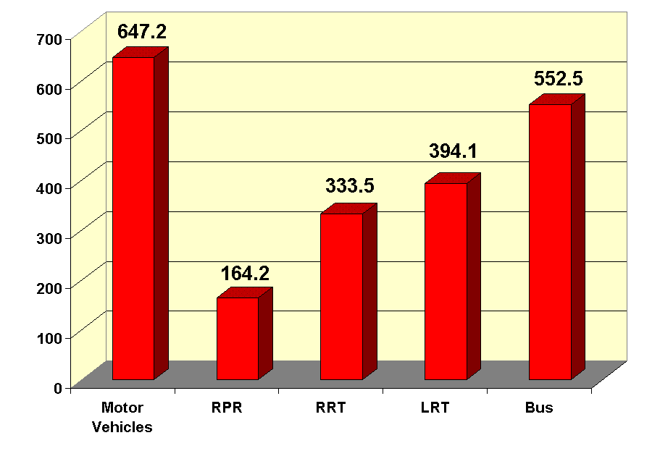
Figure 1: Example of a Figure

Table 1 shows an example of a table, where the caption should be on the top of the table.

Table 1: Example of a Table
Heading 1 | Heading 2 | Heading 3
Entry 1 | Entry 2 | Entry 3

Figure 2 is an example of an oversized figure.

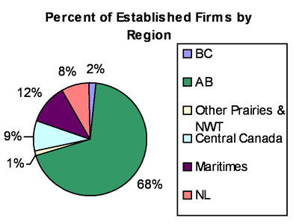

Figure 2: Example of an Oversized Figure

